ASSIGNMENT NO. 2
AIM:
Design a distributed application using RMI for remote computation where client submits two strings to the server and server returns the concatenation of the given strings.

PRE REQUSITE:
Concept of Distributed Objects and Remote Object Reference.

THEORY:
The Object Model:
An object-oriented program, for example in Java or C++, consists of a collection of interacting objects, each of which consists of a set of data and a set of methods. An object communicates with other objects by invoking their methods, generally passing arguments and receiving results. Objects can encapsulate their data and the code of their methods. Some languages, for example Java and C++, allow programmers to define objects whose instance variables can be accessed directly. However, for use in a distributed object system, an object’s data should be accessible only via its methods.
- Object references:
Objects can be accessed via object references. For example, in Java, a variable that appears to hold an object actually holds a reference to that object. To invoke a method in an object, the object reference and method name are given, together with any necessary arguments. The object whose method is invoked is sometimes called the target and sometimes the receiver.
- Interfaces:
An interface provides a definition of the signatures of a set of methods (that is, the types of their arguments, return values and exceptions) without specifying their implementation.
- Action:
An object invoking a method in another object initiates action in an object-oriented program. An invocation can include additional information (arguments) needed to carry out the method. The receiver executes the appropriate method and then returns control to the invoking object, sometimes supplying a result.
- Exception:
Exceptions provide a clean way to deal with error conditions without complicating the code. In addition, each method heading explicitly lists as exceptions the error conditions it might encounter, allowing users of the method to deal with them. A block of code may be defined to throw an exception whenever particular unexpected conditions or errors arise. This means that control passes to another block of code that catches the exception. Control does not return to the place where the exception was thrown.
- Garbage collection:
It is necessary to provide a means of freeing the space occupied by objects when they are no longer needed. A language such as Java, that can detect automatically when an object is no longer accessible recovers the space and makes it available for allocation to other objects. This process is called garbage collection.

Distributed Objects:
Distributed object systems may adopt the client-server architecture. In this case, servers manage objects and their clients invoke their methods using remote method invocation. In RMI, the client’s request to invoke a method of an object is sent in a message to the server managing the object. The invocation is carried out by executing a method of the object at the server and the result is returned to the client in another message. To allow for chains of related invocations, objects in servers are allowed to become clients of objects in other servers. Distributed objects can assume other architectural models. For example, objects can be replicated in order to obtain the usual benefits of fault tolerance and enhanced performance, and objects can be migrated with a view to enhancing their performance and availability.
Having client and server objects in different processes enforces encapsulation. That is, the state of an object can be accessed only by the methods of the object, which means that it is not possible for unauthorized methods to act on the state. Another advantage of treating the shared state of a distributed program as a collection of objects is that an object may be accessed via RMI, or it may be copied into a local cache and accessed directly, provided that the class implementation is available locally.

The Distributed Object Model:
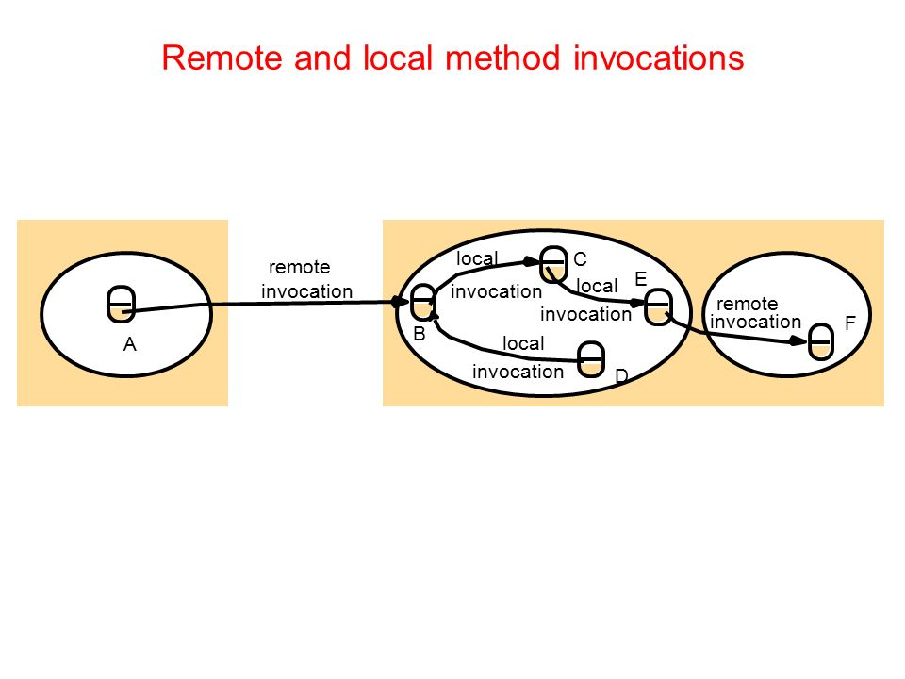

Each process contains a collection of objects, some of which can receive both local and remote invocations, whereas the other objects can receive only local invocations, as shown in Figure.
Method invocations between objects in different processes, whether in the same computer or not, are known as remote method invocations. Method invocations between objects in the same process are local method invocations.
We refer to objects that can receive remote invocations as remote objects. In Figure the objects B and F are remote objects. All objects can receive local invocations, although they can receive them only from other objects that hold references to them. For example, object C must have a reference to object E so that it can invoke one of its methods. The following two fundamental concepts are at the heart of the distributed object model:
- Remote object references:
Other objects can invoke the methods of a remote object if they have access to its remote object reference. For example, a remote object reference for B in Figure must be available to A.
- Remote interfaces:
Every remote object has a remote interface that specifies which of its methods can be invoked remotely. For example, the objects B and F in Figure must have remote interfaces.

Remote Method Invocation:
Remote method invocation (RMI) is closely related to RPC but extended into the world of distributed objects. In RMI, a calling object can invoke a method in a potentially remote object. As with RPC, the underlying details are generally hidden from the user.
The commonalities between RMI and RPC are as follows:
- They both support programming with interfaces, with the resultant benefits that stem from this approach.
- They are both typically constructed on top of request-reply protocols and can offer a range of call semantics such as at-least-once and at-most-once.
- They both offer a similar level of transparency – that is, local and remote calls employ the same syntax but remote interfaces typically expose the distributed nature of the underlying call, for example by supporting remote exceptions.
RMI Architecture:
Several separate objects and modules are involved in achieving a remote method invocation. These are shown in Figure in which an application-level object A invokes a method in a remote application-level object B for which it holds a remote object reference.
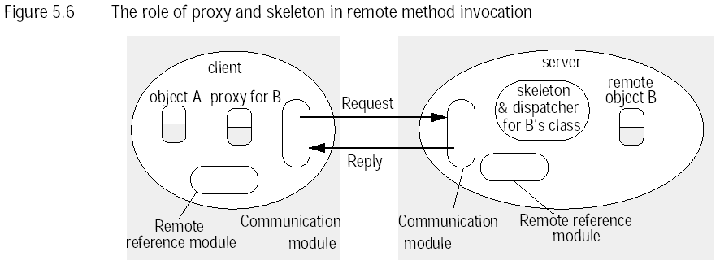
- Communication Module :
The two cooperating communication modules carry out the request-reply protocol, which transmits request and reply messages between the client and server. The contents of request and reply messages are shown in Figure . The communication module uses only the first three items, which specify the message type, its requestId and the remote reference of the object to be invoked. The operationId and all the marshalling and unmarshalling are the concern of the RMI software. The communication modules are together responsible for providing a specified invocation semantics, for example at-most-once.
The communication module in the server selects the dispatcher for the class of the object to be invoked, passing on its local reference, which it gets from the remote reference module in return for the remote object identifier in the request message.
- Remote reference module :
A remote reference module is responsible for translating between local and remote object references and for creating remote object references. To support its responsibilities, the remote reference module in each process has a remote object table that records the correspondence between local object references in that process and remote object references (which are system-wide). The table includes:
- An entry for all the remote objects held by the process. For example, in Figure the remote object B will be recorded in the table at the server.
- An entry for each local proxy. For example, in Figure the proxy for B will be recorded in the table at the client.
The actions of the remote reference module are as follows:
- When a remote object is to be passed as an argument or a result for the first time, the remote reference module is asked to create a remote object reference, which it adds to its table.
- When a remote object reference arrives in a request or reply message, the remote reference module is asked for the corresponding local object reference, which may refer either to a proxy or to a remote object. In the case that the remote object reference is not in the table, the RMI software creates a new proxy and asks the remote reference module to add it to the table.
- Servants :
A servant is an instance of a class that provides the body of a remote object. The servant eventually handles the remote requests passed on by the corresponding skeleton. Servants live within a server process. They are created when remote objects are instantiated and remain in use until they are no longer needed, finally being garbage collected or deleted.
- Proxy:
The role of a proxy is to make remote method invocation transparent to clients by behaving like a local object to the invoker; but instead of executing an invocation, it forwards it in a message to a remote object. It hides the details of the remote object reference, the marshalling of arguments, unmarshalling of results and sending and receiving of messages from the client.
A process holds a remote object reference for one proxy. The class of a proxy implements the methods in the remote interface of the remote object it represents, which ensures that remote method invocations are suitable for the type of the remote object. However, the proxy implements them quite differently. Each method of the proxy marshals a reference to the target object, its own operationId and its arguments into a request message and sends it to the target. It then awaits the reply message, unmarshals it and returns the results to the invoker.
- Dispatcher:
A server has one dispatcher and one skeleton for each class representing a remote object. In our example, the server has a dispatcher and a skeleton for the class of remote object B. The dispatcher receives request messages from the communication module. It uses the operationId to select the appropriate method in the skeleton, passing on the request message. The dispatcher and the proxy use the same allocation of operationIds to the methods of the remote interface.
- Skeleton:
The class of a remote object has a skeleton, which implements the methods in the remote interface. They are implemented quite differently from the methods in the servant that incarnates a remote object. A skeleton method unmarshals the arguments in the request message and invokes the corresponding method in the servant. It waits for the invocation to complete and then marshals the result, together with any exceptions, in a reply message to the sending proxy’s method.

Java RMI:
RMIregistry:

The RMIregistry is the binder for Java RMI. An instance of RMIregistry should normally run on every server computer that hosts remote objects. It maintains a table mapping textual, URL-style names to references to remote objects hosted on that computer. It is accessed by methods of the Naming class, whose methods take as an argument a URL-formatted string of the form:

computerName:port/objectName

where computerName and port refer to the location of the RMIregistry. If they are omitted, the local computer and default port are assumed. Its interface offers the methods all of the which can throw a RemoteException. Used in this way, clients must direct their lookup enquiries to particular hosts.
Alternatively, it is possible to set up a system-wide binding service. To achieve this, it is necessary to run an instance of the RMIregistry in the networked environment and then use the class LocateRegistry, which is in java.rmi.registry, to discover this registry. More specifically, this class contains a getRegistry method that returns an object of type Registry representing the remote binding service: public static Registry getRegistry() throws RemoteException. Following this, it is then necessary to issue a call of rebind on this returned Registry object to establish a connection with the remote RMIregistry.

CORBA-RMI:
Programming in a multi-language RMI system such as CORBA RMI requires more of the programmer than programming in a single-language RMI system such as Java RMI. In particular, the programmer defines remote interfaces for the remote objects and then uses an interface compiler to produce the corresponding proxies and skeletons. But in CORBA, proxies are generated in the client language and skeletons in the server language.
- CORBA's Object Model :
A client can be any program that sends request messages to remote objects and receives replies. The term CORBA object is used to refer to remote objects. Thus, a CORBA object implements an IDL interface, has a remote object reference and is able to respond to invocations of methods in its IDL interface. A CORBA object can be implemented by a language that is not object- oriented – for example, without the concept of class. Since implementation languages will have different notions of class, or even none at all, the class concept does not exist in CORBA. Therefore, classes cannot be defined in CORBA IDL, which means that instances of classes cannot be passed as arguments. However, data structures of various types and of arbitrary complexity can be passed as arguments.
- CORBA IDL :
A CORBA IDL interface specifies a name and a set of methods that clients can request. In more detail, the CORBA IDL provides facilities for defining modules, interfaces, types, attributes and method signatures. CORBA IDL has the same lexical rules as C++ but has additional keywords to support distribution, for example, interface, any, attribute, in, out, inout, readonly and raises. It also allows standard C++ preprocessing facilities.
- CORBA Language Mappings :
The mapping from the types in IDL to types in a given programming language is quite straightforward. For example, in Java the primitive types in IDL are mapped to the corresponding primitive types in that language. Structs, enums. and unions are mapped to Java classes; sequences and arrays in IDL are mapped to arrays in Java. An IDL exception is mapped to a Java class that provides instance variables for the fields of the exception and constructors. The mappings in C++ are similarly straightforward.
CORBA Architecture:
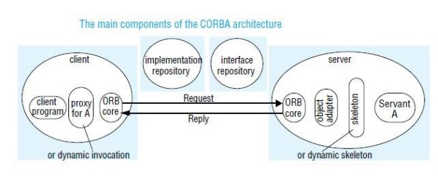
The CORBA architecture is designed to support the role of an object request broker that enables clients to invoke methods in remote objects, where both clients and servers can be implemented in a variety of programming languages.
Parts of RMI:
- Client - user interface
- Server - data source
- Stubs
  - marshals argument data (serialization)
  - unmarshals results data (deserialization)
- Skeletons (not reqd. w/Java 2)
  - unmarshals argument data
  - marshals results data
- Remote Reference Layer
  - Provides a RemoteRef object that represents the link to the remote service implementation object.
  - encodes and decodes the on-wire protocol
  - implements the remote object protocols
- Transport layer
  - The Transport Layer makes the connection between JVMs. All connections are stream-based network connections that use TCP/IP.
  - handles the underlying socket handling required for communications
    - sets up and maintains connections
    - communications related error handling

Advantages of RMI:
- Object Oriented: RMI can pass full objects as arguments and return values, not just predefined data types. This means that you can pass complex types, such as a standard Java hash table object, as a single argument.
- Mobile Behavior: RMI can move behavior (class implementations) from client to server and server to client.
- Design Patterns: Passing objects lets you use the full power of object oriented technology in distributed computing, such as two- and three-tier systems. When you can pass behavior, you can use object oriented design patterns in your solutions.
- Safe and Secure: RMI uses built-in Java security mechanisms that allow your system to be safe when users downloading implementations. RMI uses the security manager defined to protect systems from hostile applets to protect your systems and network from potentially hostile downloaded code.
- Easy to Write/Easy to Use: RMI makes it simple to write remote Java servers and Java clients that access those servers.
- Write Once, Run Anywhere : RMI is part of Java's "Write Once, Run Anywhere" approach.
- Parallel Computing: RMI is multi-threaded, allowing your servers to exploit Java threads for better concurrent processing of client requests.

Disadvantages of RMI:
- Less efficient than Socket objects.
- Assuming the default threading will allow ignoring the coding, being the servers are thread- safe and robust.
- Cannot use the code out of the scope of java.
- Security issues need to be monitored more closely.

OPERATIONAL STEPS:
Creating Distributed Applications by Using RMI
Step One: Enter and Compile the Source Code
Step Two: Generate a Stub
Step Three: Install Files on the Client and Server Machines
Step Four: Start the RMI Registry on the Server Machine
Step Five: Start the Server
Step Six: Start the Client

CONCLUSION:
In this assignment we studied what is Remote Method Invocation(RMI) and how to implement Java RMI in a distributed system.

REFERENCES:
- www.javatpoint.com
- www.tutorialspoint.com
- Herbert Schildt, “JAVA complete reference”
- Kenneth L. Calvert, Michael J. Donahoo “TCP/IP Socket in JAVA- Practical Guide”
- George Coulouris, “Distributed Systems – Concept and Design ”

